**EXPERIMENT NO : 10**

**Aim:** Design an interactive data access using Graphics (QR, BAR Code, Image etc) and generating a print form

**Theory:**

**QR Code :** Created in 1994 by Toyota subsidiary 'Denso Wave' to quickly track vehicles and parts through the company's automotive manufacturing process, QR codes are used more commonly today for logging into websites or Wi-Fi networks, sharing contact information, making mobile payments or storing data for plane and train tickets on your phone.

QR codes (short for Quick Response codes) were internationally standardized in 2000 and mobile phone users in Japan had already widely adopted the technology by 2002. Although Denso Wave still holds patents over the technology, QR codes are free for anyone to use without a license fee as long as the intellectual property is being used within the defined ISO/JIS standards. As with any other barcode, interacting with a QR code is simple enough: scan one with an image sensor such as the camera in your smartphone, the app you're using will convert the code to binary and then display the information or perform the programmed action, such as opening a website, essentially allowing real world objects to be hyperlinked to digital places.

A QR code is comprised of an array of squares, some of which are used for the image sensor to position itself (that's the large squares on three of the corners), while the rest of the cells contain version and format information as well as the data itself, of course, along with error correction coding. Whereas most of the barcodes you come across are one-dimensional, such as UPC labels on items at the store, QR codes are two-dimensional and offer many advantages. For instance, QR codes can be scanned in any direction instead of only one, they can contain thousands of alphanumeric characters versus only a dozen or so, and when configured with a high level of error correction they are particularly capable at continuing to function after sustaining damage. The more error correction a QR code has, the less data it can store and incidentally, the more data that is stored within a QR code, the more squares it will have. More squares are also required as the level of error correction is increased and artistic QR codes can forego data capacity for aesthetics by creating an image with some of the blocks.

**Bar Code :** A barcode is “A machine-readable code in the form of numbers and a pattern of parallel lines of varying widths, printed on and identifying a product.” But in truth a barcode is so much more. [Barcode systems](http://www.waspbarcode.com/barcode-labels-and-supplies) help businesses and organizations track products, prices, and stock levels for centralized management in a computer software system allowing for incredible increases in productivity and efficiency.

The lines and patterns on a barcode are actually representations of numbers and data and their development allowed basic information about a product to be easily read by an optical scanning device, [a barcode scanner](http://www.waspbarcode.com/barcode-scanners), and automatically entered into a computer system. This vastly reduced the time it took to record such information and eliminated the potential for human data entry error. Barcodes started out with simple 1-dimensional designs, consisting of basic black lines that could only be read by specially designed barcode scanners. However, today [barcodes](http://www.waspbarcode.com/) come in many shapes and sizes and a wide range of designs and many can even be read by mobile phones and other devices.

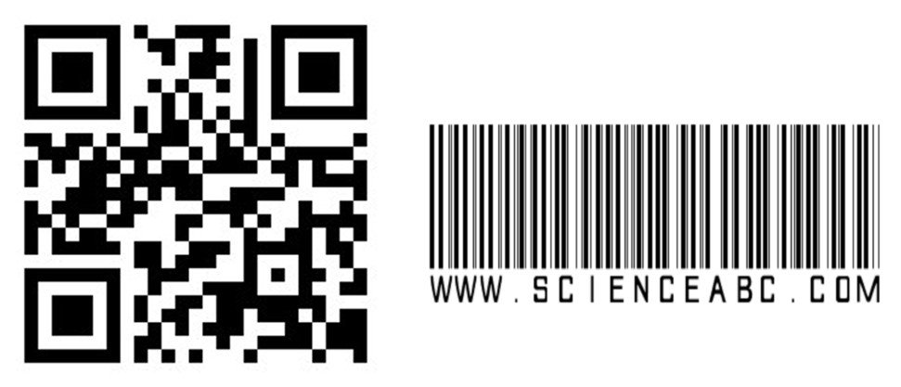

**QR Code BarCode**

**Conclusion:-**

|  |  |  |  |  |  |
| --- | --- | --- | --- | --- | --- |
| **Program Execution**  **(7)** | **Documentation**  **(2)** | **Punctuality**  **(2)** | **Viva**  **(4)** | **Experiment**  **Marks**  **(15)** | **Teacher**  **Signature**  **with date** |
|  |  |  |  |  |  |